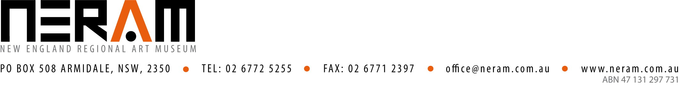

EXHIBITION PROPOSAL

NERAM welcomes proposals from artists in the New England region to exhibit new work. Submissions are accepted throughout the year and emerging, mid-career or established artists are encouraged to apply.

There are two deadlines for submissions:
- 31 March
- 30 September

Exhibition proposal submissions are assessed by the NERAM Director in consultation with NERAM staff and in accordance with policy objectives and guidelines. Submissions are assessed on artistic merit, originality, and its potential relationship with NERAM’s programs. NERAM’s exhibition policy can be accessed at https://www.neram.com.au/corporateinformation/

Applicants will be advised of the outcome of their submission approximately one month after the submission deadline. The decision of the assessment committee is final, and no correspondence will be entered into.

Application
The following information must be included in each proposal:

- A completed exhibition proposal form
Please ensure that you list all artists, curators, writers, educators and other arts professionals involved in the project.

- A current curriculum vitae (no longer than 2 pages per artist)
The CV should include all relevant education and exhibition history

- Up to 10 examples of work in one of the following formats:
  - Email .jpeg images (no larger than 10MB in total)
  - Hard copy prints (300dpi resolution, no larger than A4)

Submit applications to: exhibitions@neram.com.au
OR
Curator
NERAM
PO Box 508 Armidale NSW 2350

General Information

A Featured Artist Exhibition is usually a selling exhibition. NERAM takes 40% commission on any works sold.

Exhibition proposals will be considered for the following gallery spaces as a Featured Artist:
- Dobell Gallery (30 running metres)
- Dulce Lindsay Gallery (16 running metres)

The exhibition program for the Dobell and Dulce Lindsay Galleries are a combination of invited artists, in-house curated, touring and successful submissions.

Please keep in mind that artworks must be hung using the existing Gallery hanging system and need to be pre-prepared with d-rings. Alternatively, works on paper may be pinned directly to the walls.

NERAM will be responsible for the following costs:
- printing of standard invitations for distribution to our mailing list (including the 30 for artist use)
- postage of the invitations to members of NERAM
- local publicity, promotion and advertising in local media as determined by NERAM
- opening costs if applicable including refreshments
- insurance cover for the Work, or Works while on exhibition

The Artist will be responsible for the following costs:
- transportation of the Work, or Works, to and from NERAM
- insurance of the Work, or Works while in transit to and from NERAM
- additional installation materials, equipment and requirements
- exhibition support material
- educational material if required
- cost and postage of invitations per person if more than 30 guests are to be invited by the Artist

NERAM Exhibition Proposal Form
Please type or print clearly in block letters

Full name:
Residential address:
Postal address:
(if different from residential address)
Telephone:
Mobile:
Email:
Website (if applicable):
Main practice:
(e.g. painting, sculpture, multimedia photography, etc)

Proposed exhibition title:

Proposed project/exhibition description:
Please provide a description of the content of the proposed exhibition. Is it relevant to specific interests in the community? Please indicate if there are any specific issue involving delivery and/or installation that may require attention (expand window if necessary).

Public Programs:
Are you interested in presenting a public program? (please tick) □ YES □ NO
If so, provide details of what type of program(s):

Application checklist:
Please indicate that the following information is included in your proposal.
□ Completed exhibition proposal form
□ Current CV
□ Up to 10 examples of current or recent work

