Friends of NERAM Membership New & Renewal 2023 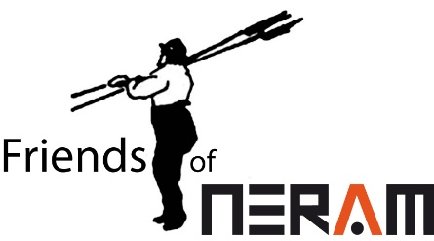
Dear Friends,
Your membership goes a long way in supporting the operational needs at NERAM as well as sponsoring exhibitions, and funding special events like the After Dark series, the shop refurbishment and artwork restoration. We invite you to renew your Friends of NERAM membership over the next month. Your new membership will be valid to 31 March 2024.
Thank you for your continued support and for being a Friend of NERAM.
Debra Kelliher
Chair, Friends of NERAM Inc
RENEWING | Membership No. (if known) | NEW MEMBER
Title/First name/Surname

Email

Phone/mobile

Street address

Town/State/Postcode

No. of children under 18 (in Family membership)

Membership Categories | $ | Your choice
Individual | 60.00
Family – 2 adults & children under 18 | 90.00
Student/Pensioner single * | 25.00
Pensioner couple | 50.00
Registered Volunteer | 25.00
Art teacher (Member of VADEA) | 50.00
*Must be a fulltime student, pension card/healthcare card holder or reside interstate.
Add a donation
Your generosity helps NERAM in so many ways to provide the variety of programs, exhibitions and activities available.
NERAM Ltd is endorsed as a Deductible Gift Recipient. Donations of $2.00 or more are tax deductible. A separate receipt will be issued for your donation and donations of $500 and above will be acknowledged on the NERAM Donor Board. If you wish to remain anonymous, please tick here. ____

Total (Membership Category + Donation if making one) |  | $

Payment Options | 1. By direct deposit to BSB 932-000 Account no. 100306260. Reference is your name and/or membership number.  Scan and email this form with the date and amount of payment to fonmembership@gmail.com . We will send your receipt and membership card.  2. At the front desk at NERAM.

Thank you for supporting New England Regional Art Museum.
Friends of NERAM Gift Membership

Gift Recipient
Title/First name/Surname

Email

Phone/mobile

Street address

Town/State/Postcode

No. of children under 18 (in Family membership)

Membership Categories | $ | Your choice
Individual | 60.00
Family – 2 adults & children under 18 | 90.00
Student/Pensioner single * | 25.00
Pensioner couple | 50.00
Registered Volunteer | 25.00
Art teacher (Member of VADEA) | 50.00
*Must be a fulltime student, pension card/healthcare card holder or reside interstate.

Gift Giver | Already a Friend? Yes / No
Title/First name/Surname

Email

Phone/mobile

Street address

Town/State/Postcode

Total payment | $

Payment Options | 1. By direct deposit to BSB 932-000 Account no. 100306260. Reference is your name and/or membership number.  Scan and email this form with the date and amount of payment to fonmembership@gmail.com . We will send your receipt and membership card.  2. At the front desk at NERAM.

Thank you for supporting New England Regional Art Museum.

