BLACK GULLY
FESTIVAL
Day/date: Saturday 7 November 2026

Time ( please tick):


MAKERS MARKET AND FOOD STALLS
NERAM Creeklands 106-114 Kentucky Street
ARMIDALE NSW 2350

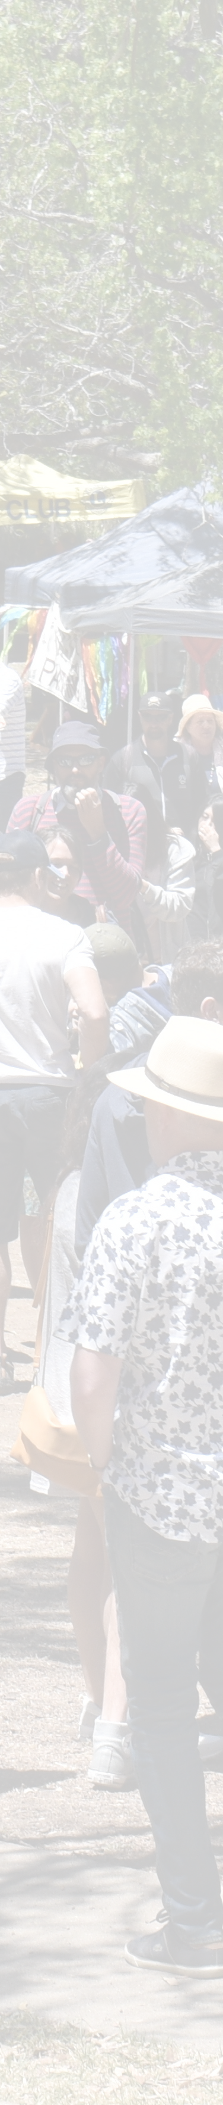
 10am to 4pm ( Market Trading)

Late stall - as per arrangement with festival organisers

INSURANCE & CERTIFICATION

All stallholders are required to have Public Liability insurance. For all stall holders - Do you have Public Liability insurance?
YES – Please provide a copy of your current Public Liability certificate of currency with your market stallholder booking form.

For food stall holders only - Do you have Food Handling & Safety certificate?

YES – Please provide a copy of your current Food Handling & Safety certificate with your market stallholder booking form.

NO – Please contact Front of House at NERAM.

STALLHOLDER FEES & PAYMENT DETAILS ( Please tick)

3 m x 3 m Makers Stall $40 . 00 3 m x 3 m Food Stall $50 . 00
Extra 3 m x 3 m Food Stall $30 . 00

Payment and your booking form must be received by NERAM to secure your Market stall by Friday 4 pm 16 October 2026 .

Please see payment details on next page.

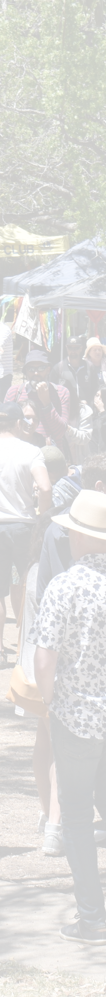
Payments can be made via EFT, Cash, or Credit Card. Please provide your details and payment method:

STALL HOLDER NAME:
CONTACT PERSON:
TELEPHONE:
EMAIL:

My Stallholder fees will be paid by:

Cash ( To be paid at NERAM)
EFT ( BSB 932 000, Account number 704793,Reference BG2025 Surname) Credit Card ( Visa / Mastercard, Reference: BG 2025 Surname)

Date of payment:

Name on card: Card Number: Expiry Date: / 3 - Digit Security Code: Signature:

I have read and understand the Terms & Conditions of being involved as a Stallholder at the 2026 Black Gully Music Festival Markets.

Signed: Dated:

Please email your completed booking form & required certifications to foh@ neram. com. au and advise payment arrangements,

OR Mail your completed booking form to:

Black Gully Community Stalls NERAM
PO Box 508
ARMIDALE NSW 2350

